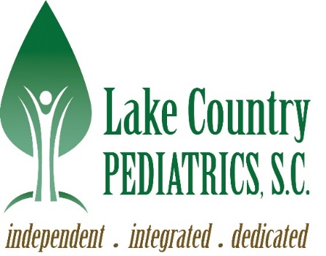

Consent to Share Protected Health Information

I, __________________________,give permission for Lake Country Pediatrics, S.C. to share
my protected health information with:____________________________/_________________.
Name of person(s) / Relationship to Patient

General Health ______ Yes ______ No (For 18 and over only)
Mental Health _______ Yes ______ No
Sexual Health _______ Yes ______ No

_____________________________________ ______________________
Patient Signature Date

_____________________________________ ______________________
Witness - LCP Staff Signature Date

____________________________ _________
Patient’s Phone # Patient’s Age
__________________________________
Patient’s Email address – over 18 only

**** Consent will be reviewed annually ****
970 S. Silver Lake St Ste 102 2750 Golf Rd Ste B
Oconomowoc, WI 53066 Delafield, WI 53018
Ph: (262)569-7100 Fax: (262)567-6295 Ph: (262)646-2282 Fax: (262)646-7535

